**Tracking System For Packages**

**Reg No :** 41731092

**Name :** P. Purna Sai

**Branch :** B.E CSE-AI (A3)

**Problem Statement :**

The code aims to simulate an order management system to track the product by its Order id for an e-commerce company in India. It will display the order id’s of ordered data and stores it in a list. It provides functions to track the package status, get customer details, and location details based on the order ID provided by the user.

**Aim :**

The aim of this code is to simulate a basic e-commerce system by providing functions to track and retrieve order details and status an customer details .

**Algorithm:**

1. The script imports the 'random' and 'string' modules in order to generate random data for orders.
2. The 'generate_order_data()' function generates a dictionary with randomly generated values for order ID, order details, status, location, and customer details.
3. The 'generate_customer()' function generates a dictionary with randomly generated values for first name, last name, phone, email, and any other customer details that may be added.
4. The 'generate_location()' function generates a dictionary with randomly generated values for city, country, pincode, and any other location details that may be added.
5. The script display 100 sample orders ids using a 'for' loop and stores them in a list.
6. Three functions are provided to track the status of an order, retrieve customer details for an order, and retrieve location details for an order.
7. The user is prompted to enter an order ID, and the status, customer details, and location details are retrieved using the provided functions.
8. Store randomly generated order data by creating a list “order_data_list” and append “order_data” to it.
9. Define a function “track_package_status(order_id)” to get the package status based on the order ID provided by the user.
10. Define a function “get_customer_details(order_id)” to get customer details based on the order ID provided by the user.
11. Define a function “get_location_details(order_id)” to get location details based on the order ID provided by the user.
12. Get the order ID from the user and call the “track_package_status()”, “get_customer_details()”, and “get_location_details()” functions to retrieve the status, customer details, and location details of the order.

**Prerequsites:**

To run this code, Python version 3 or higher is required.

**How to access Code :**

1. Copy the code into a new Python file.
2. Save the file with a “.py” extension.
3. Open the file in a Python interpreter or IDE.
4. Run the code.
5. Enter an order ID when prompted to track the status, customer details, and location details for that order

**Code:**

**import** **random**

**import** **string**

# Generate random order data

**def** **generate_order_data**():

alphabets = ''.join(random.choices(string.ascii_uppercase, k=**4**))

numbers = str(random.randint(**100000**,**999999**))

orders = alphabets + numbers

order_id = orders

order_details = str(order_id)

status = random.choice(["Pending", "Shipped", "Delivered"])

location = generate_location()

customer_details = generate_customer()

# Add other features as needed

**return** {"order_id": order_id, "order_details": order_details, "status": status, "location": location, "customer_details": customer_details}

**def** **generate_customer**():

first_name = random.choice(["John", "Mary", "David", "Lisa", "Steven", "Emily", "Michael", "Rachel", "Daniel", "Julia"])

last_name = random.choice(["Smith", "Johnson", "Brown", "Lee", "Garcia", "Martinez", "Davis", "Hernandez", "Miller", "Gonzalez"])

phone = str(random.randint(**1000000000**, **9999999999**))

email = first_name.lower() + "." + last_name.lower() + "@" + random.choice(["gmail.com", "yahoo.com", "hotmail.com", "outlook.com"])

# Add other customer details as needed

**return** {"first_name": first_name, "last_name": last_name, "phone": phone, "email": email}

# Generate random location in India

**def** **generate_location**():

city = random.choice(["Mumbai", "Delhi", "Bangalore", "Hyderabad", "Chennai", "Kolkata", "Pune", "Ahmedabad", "Jaipur", "Surat"])

country = "India"

pincode = str(random.randint(**100000**, **999999**))

# Add other location features as needed

**return** {"city": city, "country": country, "pincode": pincode}

# Store randomly generated order data

order_data_list = []

**for** i **in** range(**100**): # Generate 10 random orders

order_data = generate_order_data()

order_data_list.append(order_data)

order_ids = []

**for** order **in** order_data_list:

order_ids.append(order["order_id"])

**print**("**\n\n**Product order_ids in our Database ::: ",order_ids)

# Function to track package status based on order ID

**def** **track_package_status**(order_id):

**for** order **in** order_data_list:

**if** order["order_id"] == order_id:

**return** order["status"]

**return** "Order ID not found"

# Function to get customer details for order ID

**def** **get_customer_details**(order_id):

**for** order **in** order_data_list:

**if** order["order_id"] == order_id:

**return** order["customer_details"]

**return** "Order ID not found"

# Function to get customer details for order ID

**def** **get_location_details**(order_id):

**for** order **in** order_data_list:

**if** order["order_id"] == order_id:

**return** order["location"]

**return** "Order ID not found"

# Test tracking package status

order_id_to_track = input("**\n**Enter your order id to track :: ")# Change to the desired order ID to track

**print**("**\n\n\n\n**Details of order :: ",order_id_to_track)

status = track_package_status(order_id_to_track)

**print**("Status ::: {}".format(status))

# Test getting location for order ID

location = get_location_details(order_id_to_track)

**print**("location ::: {}".format(location))

# Test getting customer details for order ID

customer_details = get_customer_details(order_id_to_track)

**print**("Customer details ::: {}".format(customer_details))

**print**("**\n**")

**Output:**

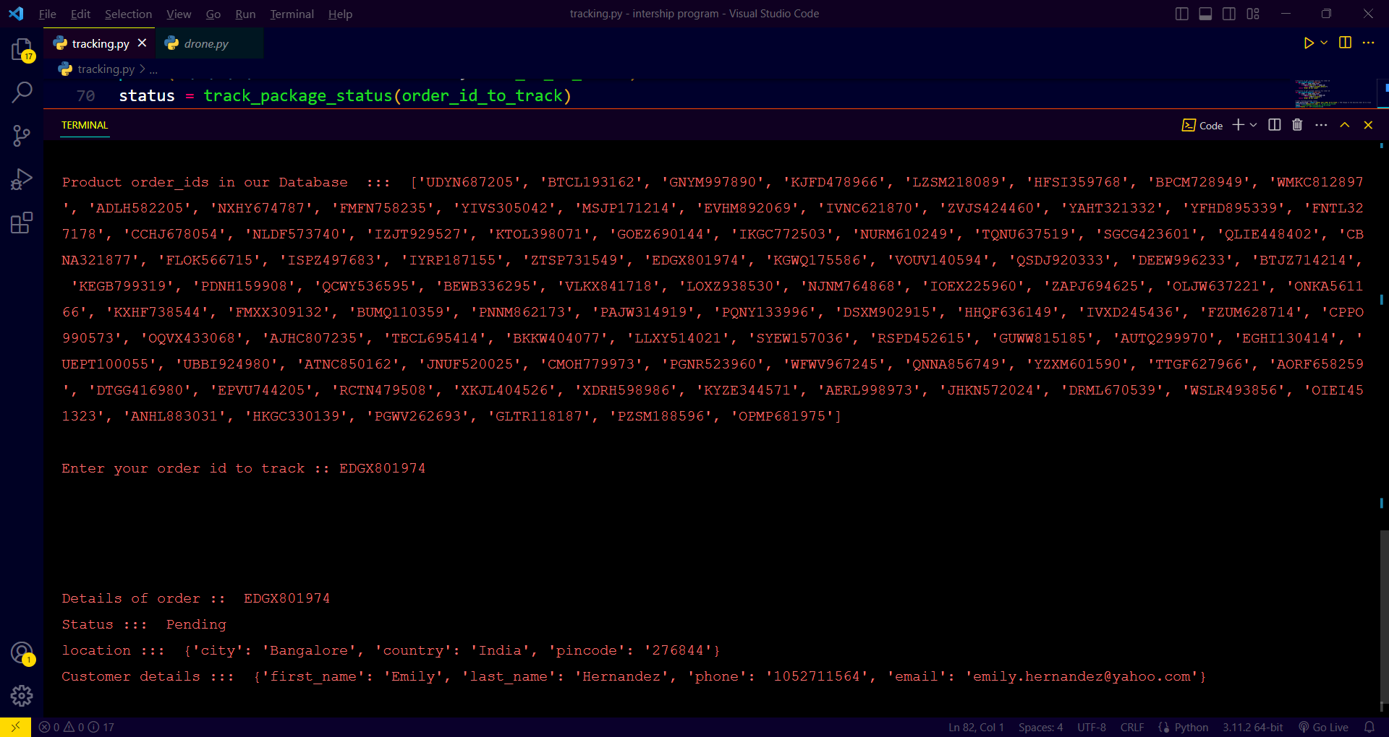

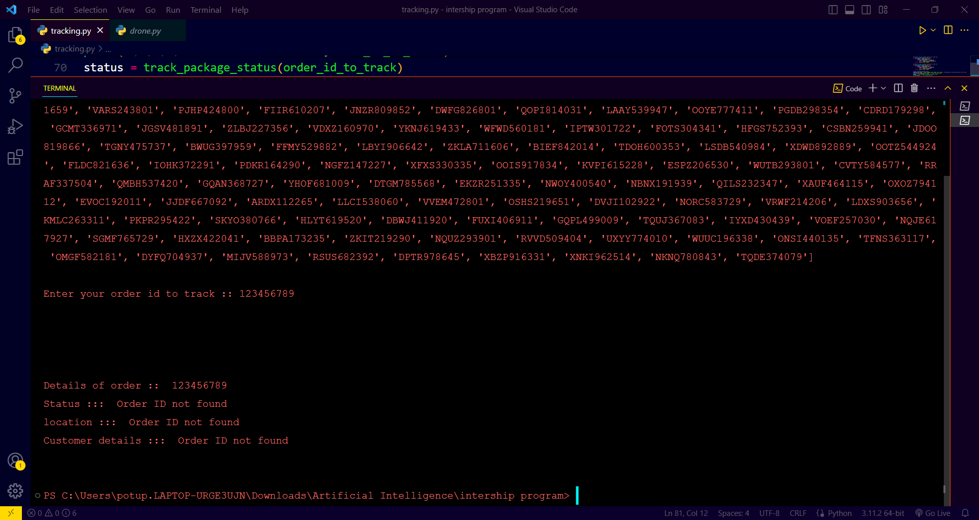

**Conclusion:**

The provided code generates display the ordered data as a sample consisting of an order ID, order details, status, location, and customer details. It then stores this data in a list and provides functions to track the package status, get the customer details, and get the location details based on the order ID. This code can be used to simulate and test order tracking systems and customer data management in e-commerce applications.